**CrowSoft**

**VMWare user Guide**

|  |  |  |  |
| --- | --- | --- | --- |
| **Version** | **Date** | **Affected Sections(s)** | **Author** |
| 1.0 | 17/3/2019 | Initial Draft | Colin Kenny |
| 1.1 | 18/03/2019 | Amended Connection | Michael McFadden |

Contents

Prerequisites 2

Connection 2

Set up 3

Creating a VM 4

Training: 7

## Prerequisites

User must have been given access by the admin.

User needs to install FortiClient on their machine

<https://forticlient.com/>

## Connection

Connection Name LYIT-CDC Letterkenny

Remote Gateway fg-vpn.lyit-cdc.net

Auth Method Pre-shared Key Link: <pwd_from _admin>

CrowSoft IP 172.28.2.46

User/password Admin will supply login details

### Set up

Create a new connection

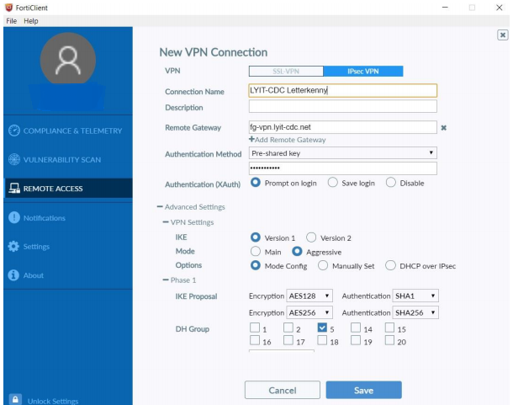

Connect to LYIT Data Center

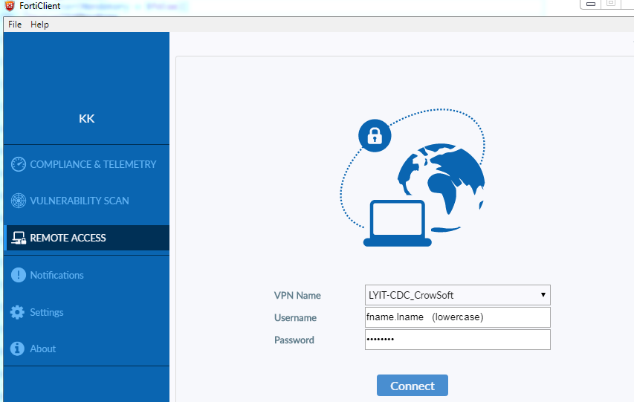

Successful login should display something similar

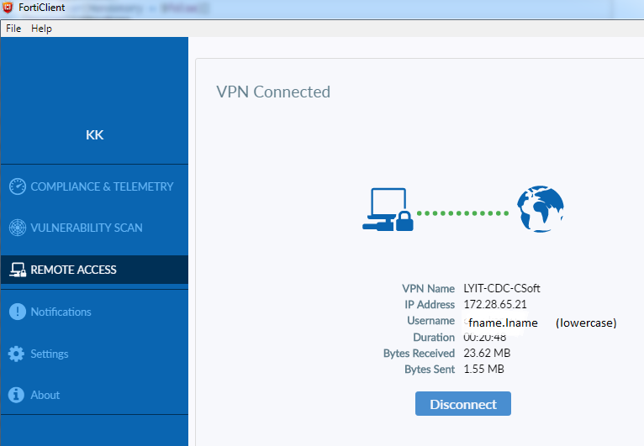

Enter url and proceed to VMWARE ESXi login entering same login credentials

<https://172.28.2.46/>

You are now connected to the LYIT Computing Data Center

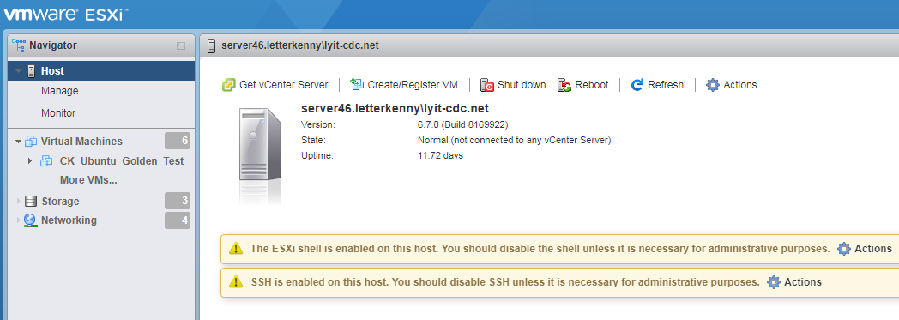

## Creating a VM

Click on **Create/Register VM** ­­on Host display

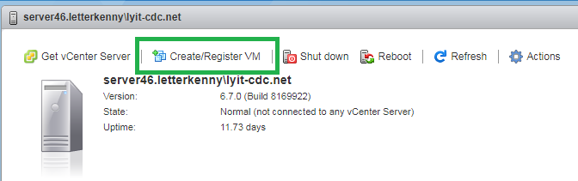

Create a new Virtual machine and click next

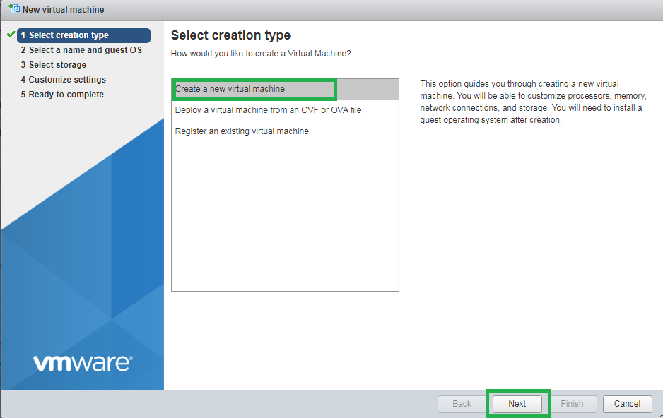

Name new VM adding OS & Version you require

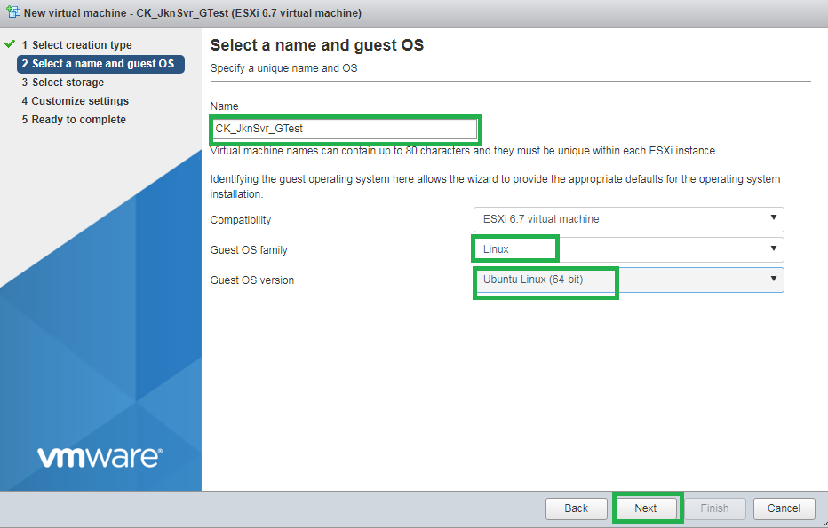

Select Storage option **2tb**

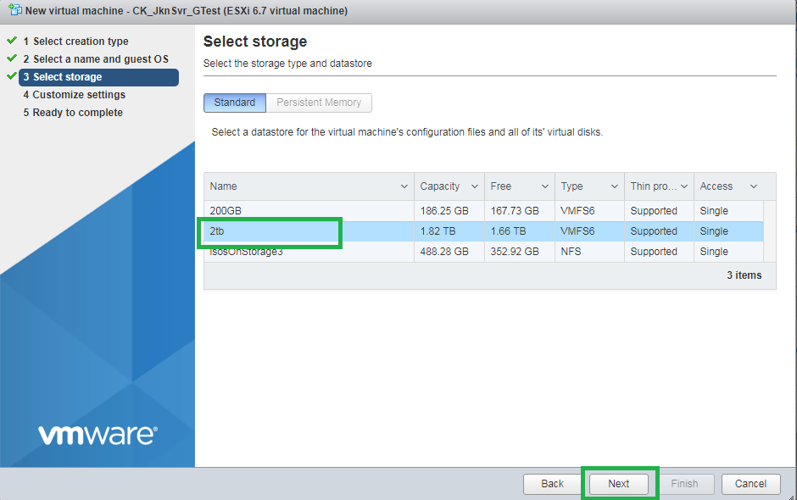

Configure the hardware for the VM click next and Finish

CD/DVD drive can be pointed to Datastore ISO file here (done in next step)

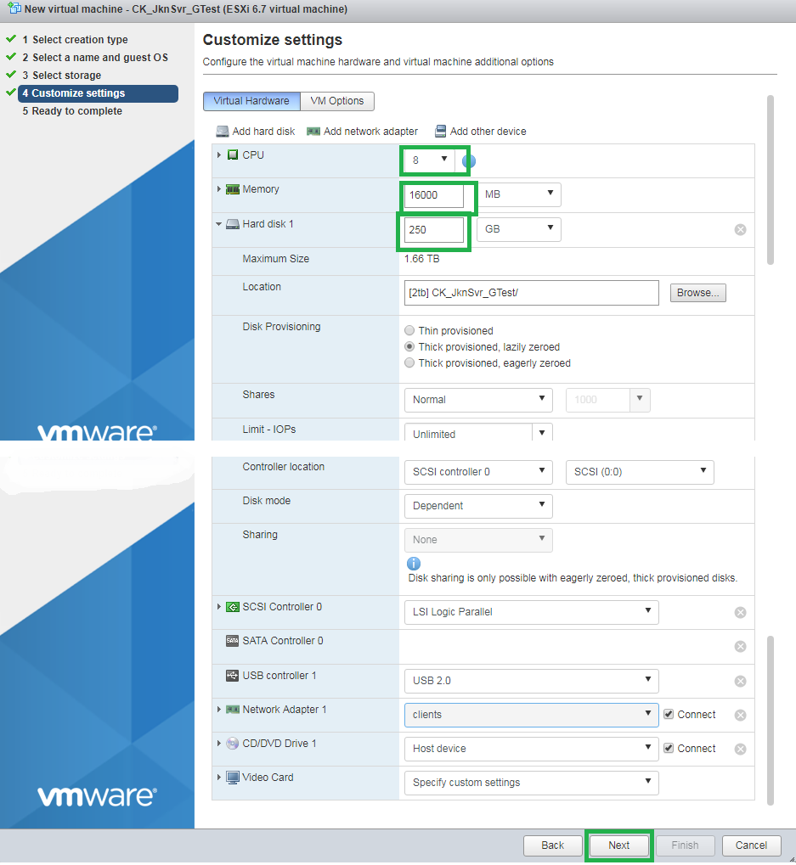

## Installing Operating system

Open newly created VM click on Edit on toolbar at the top

CD/DVD option choose **Datastore ISO file** checking the **Connect** box

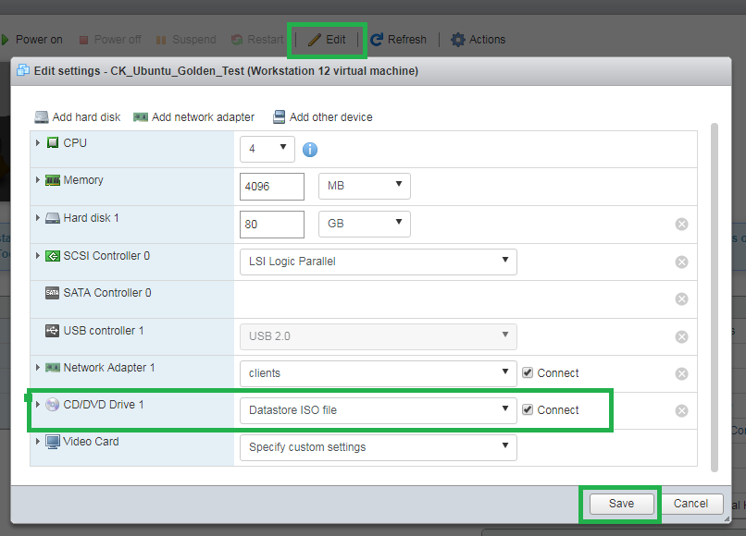

Select **isosOnStorage3** choosing you ISO image this example **UB1604**

Click **Select** and **Save**

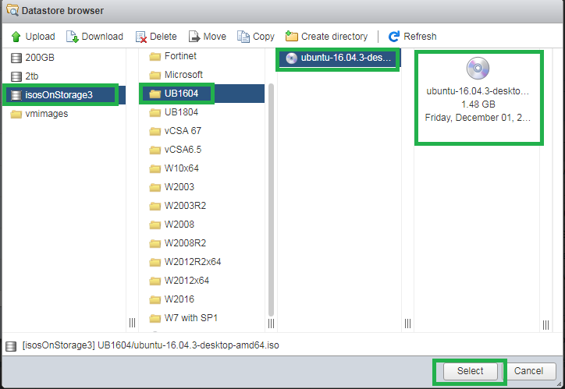

Power on the VM and proceed to Install OS

Revert CD/DVD setting when install is complete



## Training: